Portfolio Website Content:

Welcome to My Portfolio

Medication care that supports both recovery and life quality

About Me
My name is Rishi Tandon, I am a registered pharmacist who specializes in disability and rehabilitation treatment. I have a passion of assisting patients to become independent and confident with safe and individualized medication care. I have been working with rehabilitation teams to treat people who have experienced the spinal cord injuries, stroke, and other neurological conditions. I maintain effective communication with both patients and caregivers and I promote their dignity throughout the process. By volunteering in the community, I helped needy disabled people by providing them with free counseling and medications advice. These experiences still inform my faith in affordable and friendly healthcare to everyone.
Rishi’s Unique Selling Point (USP)
A pharmacist who specializes in disability and rehabilitation care, combining clinical expertise with deep empathy to help patients gain independence, dignity, and confidence in managing their health.

Services

Medication Therapy Management
Optimizing medication plans to improve recovery outcomes, reduce side effects, and support long-term health.

Rehabilitation Pharmaceutical Care
Specialized care for patients with spinal cord injuries, stroke recovery, cerebral palsy, and neurological disabilities.

Patient and Caregiver Education
Clear guidance on safe medication use, adherence, and drug interactions to build confidence and independence.

Capability Statement

Epidemiology and Data Analysis
- 26/10/2025 09:14 AM

Collaborative and Interdisciplinary Practice
- 26/10/2025 09:14 AM

Cultural Competency and Community Engagement
- 26/10/2025 09:14 AM

Health Promotion and Program Delivery
- 26/10/2025 09:14 AM

Testimonials
He shows a strong commitment to ethical pharmacy practice and patient advocacy. I have seen him communicate with compassion even in challenging situations.
Liam Peterson: Clinical Supervisor

Portfolio & Achievements


GPAT Entrance Exam

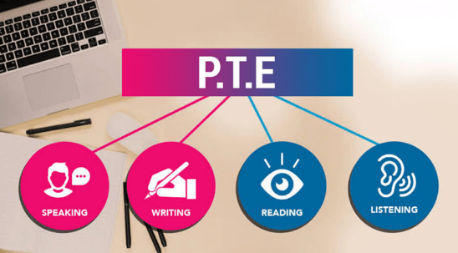
PTE Academic

Academic Literature Reflections

Pharmacotherapy and the Role of Pharmacists in Rehabilitation Medicine

Analysis of Clinical Pharmacists' Interventions in a Rehabilitation Setting

Pharmacy Students' Attitudes Toward Persons With Disabilities

Improving Pharmacy Care for Patients With Disabilities

Contact

- Sydney NSW, Australia
- +61- 478 724 239
- rishitandon9k@gmail.com
- Mon-Fri - 08:00-19:00

